SWT 22022 – Practical for Internet Application Development
Department of Information and Communication Technology
Faculty of Technology
Lab sheet :06
Reg. Number: SEU/IS/20/ICT/084
Academic Year :2020/2021
Date: 2024.07.01
Practical No :06

Title: Introduction to AJAX.
Aims:
• Grasping Asynchronous Concepts and AJAX Significance
• Mastering Asynchronous Request Handling with XMLHttpRequest
• Proficiency in Asynchronous Request Processing Using the fetch API
• Update content, validate forms, AJAX
• Practical Application and User Experience Enhancement
Tasks:
• Making Asynchronous Requests with XMLHttpRequest.
• Making Asynchronous Requests with the fetch API.
• Updating Web Content Without Page Reload.

Activities :

1. Making Asynchronous Requests with XMLHttpRequest
I. Example 01 :
<script>
function loadDoc() {
var xhttp = new XMLHttpRequest();
xhttp.onreadystatechange = function() {
if (this.readyState == 4 && this.status == 200) {
document.getElementById("demo").innerHTML =
this.responseText;
}
};
xhttp.open("GET", "info.txt", true);
xhttp.send();
}
</script>
<!DOCTYPE html>
<html lang="en">
<head>
<meta charset="UTF-8">
<meta name="viewport" content="width=device-width, initial-scale=1.0">
<title>Document</title>
<link rel="stylesheet" href="https://stackpath.bootstrapcdn.com/bootstrap/4.5.2/css/bootstrap.min.css">
</head>
<body>

<div class="container mt-5">
<h2>Content Loader</h2>

<div id="demo" class="border p-3 mb-3">Content will appear here...</div>

<button onclick="loadDoc()" class="btn btn-primary">Load Data</button>
</div>
<script>
function loadDoc() {
var xhttp = new XMLHttpRequest();
xhttp.onreadystatechange = function() {
if (this.readyState == 4 && this.status == 200) {
document.getElementById("demo").innerHTML = this.responseText;
}
};
xhttp.open("GET", "info.txt", true);
xhttp.send();
}
setInterval(loadDoc, 5000);
</script>
<script src="https://cdn.jsdelivr.net/npm/bootstrap@5.3.3/dist/js/bootstrap.bundle.min.js" integrity="sha384-YvpcrYf0tY3lHB60NNkmXc5s9fDVZLESaAA55NDzOxhy9GkcIdslK1eN7N6jIeHz" crossorigin="anonymous"></script>
</body>
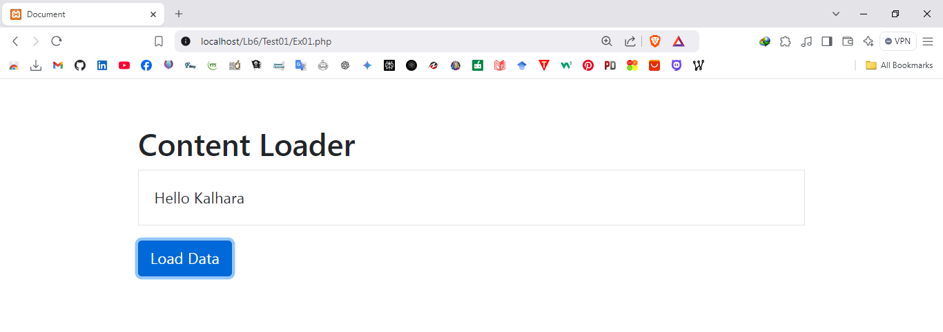
</html>
II. Example 02 :

document.getElementById("fetchContent").addEventListener("click",fetchContentWithXMLHttpRequest);
function fetchContentWithXMLHttpRequest() {
var xhr = new XMLHttpRequest();
xhr.open("GET", "https://www.w3schools.com/html/html_intro.asp",true);
xhr.onreadystatechange = function () {
if (xhr.readyState === 4) {
if (xhr.status === 200) {
displayContent("output", xhr.responseText);
} else {
displayError("output", "Failed to fetch content with XMLHttpRequest.");
}
}
};
xhr.send();
}
function displayContent(targetId, content) {
var outputElement = document.getElementById(targetId);
outputElement.textContent = content;
}
function displayError(targetId, errorMessage) {
var outputElement = document.getElementById(targetId);
outputElement.textContent = "Error: " + errorMessage;
}

Ex01.php
<!DOCTYPE html>
<html lang="en">
<head>
<meta charset="UTF-8">
<meta name="viewport" content="width=device-width, initial-scale=1.0">
<title>Fetch Content Example</title>
<link href="https://stackpath.bootstrapcdn.com/bootstrap/4.5.2/css/bootstrap.min.css" rel="stylesheet">
</head>
<body class="bg-light">
<div class="container mt-5">
<h1 class="text-center">Fetch Content Example</h1>
<div class="text-center mb-3">
<button id="fetchContent" class="btn btn-primary">Fetch Content</button>
</div>
<div id="output" class="border rounded p-3 bg-white"></div>
</div>

<script src="script.js"></script>
<script src="https://cdn.jsdelivr.net/npm/bootstrap@5.3.3/dist/js/bootstrap.bundle.min.js" integrity="sha384-YvpcrYf0tY3lHB60NNkmXc5s9fDVZLESaAA55NDzOxhy9GkcIdslK1eN7N6jIeHz" crossorigin="anonymous"></script>
</body>
</html>

Script.js

document.getElementById("fetchContent").addEventListener("click", fetchContentWithXMLHttpRequest);

function fetchContentWithXMLHttpRequest() {
var xhr = new XMLHttpRequest();
xhr.open("GET", "https://getbootstrap.com/", true);

xhr.onreadystatechange = function () {
if (xhr.readyState === XMLHttpRequest.DONE) {
var outputElement = document.getElementById("output");
if (xhr.status === 200) {
outputElement.innerHTML = xhr.responseText;
} else {
outputElement.textContent = "Error: " + xhr.status + " - Failed to fetch content.";
}
}
};

xhr.send();
}

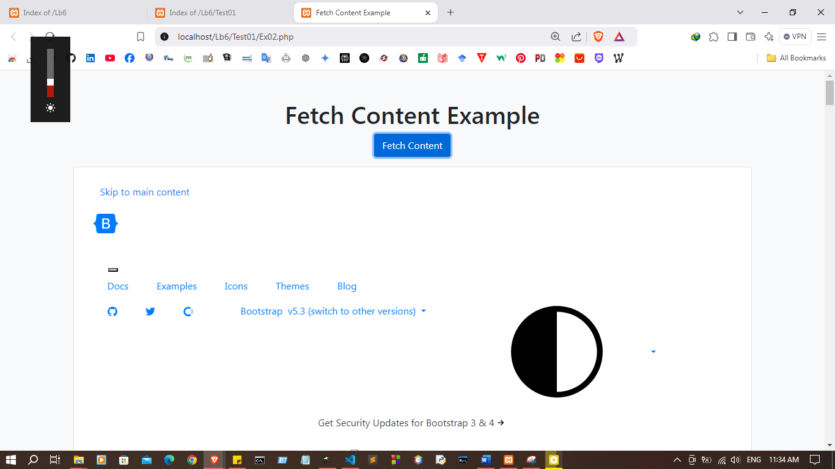

2. Making Asynchronous Request with the fetch API

document.getElementById("fetchContent").addEventListener("click",fetchContentWithFetchAPI);
function fetchContentWithFetchAPI() {
fetch("https://www.w3schools.com/html/html_intro.asp").then(response => {
if (response.ok) {
return response.text();
} else {
throw new Error("Failed to fetch content with fetch API.");
}
}).then(content => {
displayContent("output", content);
}).catch(error => {
displayError("output", error.message);
});
}
function displayContent(targetId, content) {
var outputElement = document.getElementById(targetId);
outputElement.textContent = content;
}
function displayError(targetId, errorMessage) {
var outputElement = document.getElementById(targetId);
outputElement.textContent = "Error: " + errorMessage;
}

Index.php

<!DOCTYPE html>
<html lang="en">
<head>
<meta charset="UTF-8">
<meta name="viewport" content="width=device-width, initial-scale=1.0">
<title>Fetch Content Example</title>
<link href="https://stackpath.bootstrapcdn.com/bootstrap/4.5.2/css/bootstrap.min.css" rel="stylesheet">
</head>
<body>
<div class="container my-5">
<h1 class="text-center mb-4">Content</h1>
<div class="text-center">
<button id="fetchContent" class="btn btn-primary">Content</button>
</div>
<div id="output" class="mt-4 p-3 border rounded bg-light" style="white-space: pre-wrap;"></div>
</div>

<script src="script.js"></script>
<script src="https://stackpath.bootstrapcdn.com/bootstrap/4.5.2/js/bootstrap.bundle.min.js"></script>
</body>
</html>

Script.js

document.getElementById("fetchContent").addEventListener("click",fetchContentWithFetchAPI);
function fetchContentWithFetchAPI() {
fetch("https://getbootstrap.com/").then(response => {
if (response.ok) {
return response.text();
} else {
throw new Error("Failed to fetch content with fetch API.");
}
}).then(content => {
displayContent("output", content);
}).catch(error => {
displayError("output", error.message);
});
}
function displayContent(targetId, content) {
var outputElement = document.getElementById(targetId);
outputElement.textContent = content;
}
function displayError(targetId, errorMessage) {
var outputElement = document.getElementById(targetId);
outputElement.textContent = "Error: " + errorMessage;
}

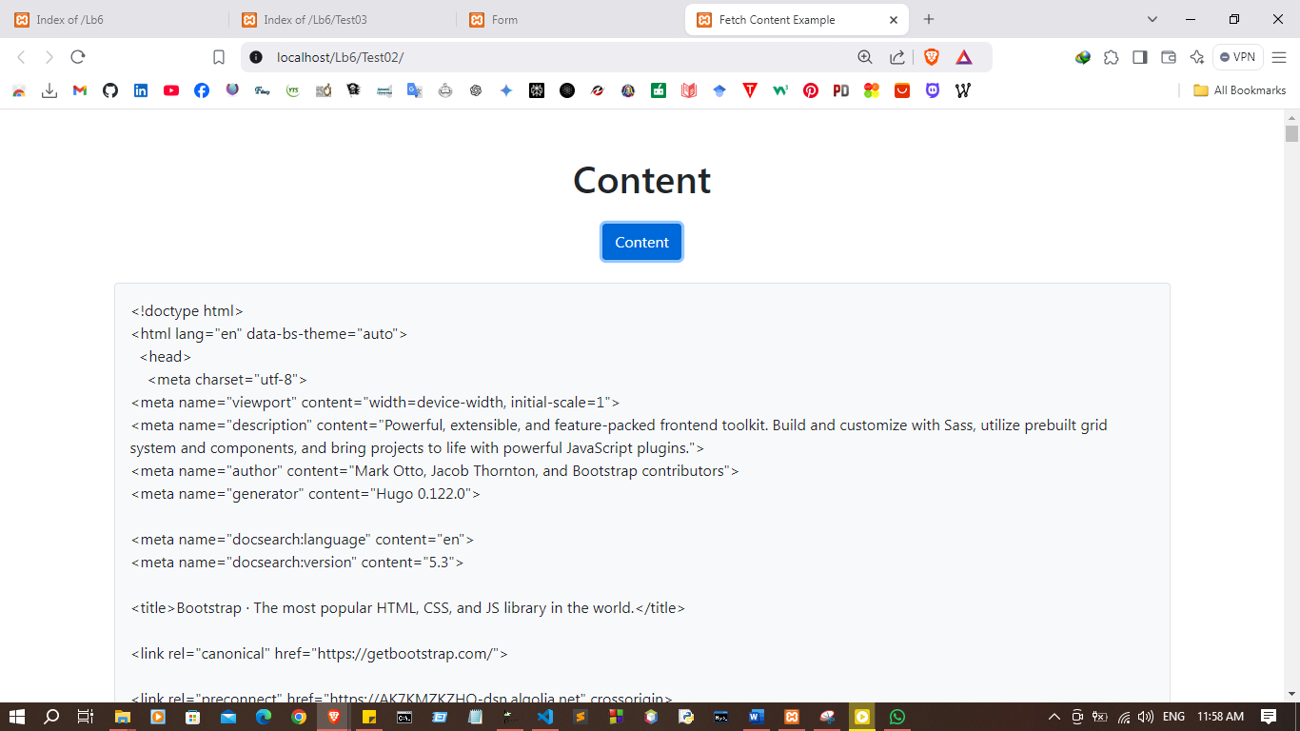
3. Updating Web Content Without Page Reload

document.getElementById("submitForm").addEventListener("click",submitForm);
function submitForm() {
var form = document.getElementById("myForm");
var name = form.elements["name"].value;
var email = form.elements["email"].value;
var outputElement = document.getElementById("formOutput");
if (name && email) {
var formData = new FormData(form);
var xhr = new XMLHttpRequest();
xhr.open("POST", "process.php", true);
xhr.onload = function() {
if (xhr.status === 200) {
outputElement.innerHTML = xhr.responseText;
} else {
outputElement.innerHTML = "Form submission failed.";
}
};
xhr.send(formData);
} else {
outputElement.innerHTML = "Please fill in all fields.";
}
}
setTimeout(function () {
var contentElement = document.getElementById("content");
contentElement.textContent = "This is updated content using AJAX!";
}, 5000);

Index.php
<!DOCTYPE html>
<html lang="en">
<head>
<meta charset="UTF-8">
<meta name="viewport" content="width=device-width, initial-scale=1.0">
<title>Form</title>
<link href="https://stackpath.bootstrapcdn.com/bootstrap/4.5.2/css/bootstrap.min.css" rel="stylesheet">
</head>
<body>
<div class="container my-5">
<h1 class="text-center mb-4">Submission</h1>
<form id="myForm">
<div class="form-group">
<label for="name">Name</label>
<input type="text" class="form-control" id="name" name="name" required>
</div>
<div class="form-group">
<label for="email">Email</label>
<input type="email" class="form-control" id="email" name="email" required>
</div>
<button type="button" id="submitForm" class="btn btn-primary">Submit</button>
</form>
<div id="formOutput" class="mt-4 p-3 border rounded bg-light"></div>
<div id="content" class="mt-4 p-3 border rounded bg-light">
This content will update
</div>
</div>
<script src="script.js"></script>
<script src="https://stackpath.bootstrapcdn.com/bootstrap/4.5.2/js/bootstrap.bundle.min.js"></script>

</body>
</html>

process.php
<?php
session_start();
if ($_SERVER["REQUEST_METHOD"] == "POST") {
$name = isset($_POST['name']) ? htmlspecialchars($_POST['name']) : '';
$email = isset($_POST['email']) ? htmlspecialchars($_POST['email']) : '';
if (!empty($name) && !empty($email)) {

$message = "Thank you, $name! Your email address ($email) has been submitted successfully.";
} else {
$message = "Please fill in all fields.";
}
} else {
$message = "Invalid request method.";
}
?>
<!DOCTYPE html>
<html lang="en">
<head>
<meta charset="UTF-8">
<meta name="viewport" content="width=device-width, initial-scale=1.0">
<title>Form Submission Result</title>
<link href="https://stackpath.bootstrapcdn.com/bootstrap/4.5.2/css/bootstrap.min.css" rel="stylesheet">
</head>
<body>
<div class="container my-5">
<h1 class="text-center mb-4">Submission Result</h1>
<div class="alert alert-info" role="alert">
<?php echo $message; ?>
</div>
<a href="index.html" class="btn btn-primary">Go Back</a>
</div>
<script src="https://stackpath.bootstrapcdn.com/bootstrap/4.5.2/js/bootstrap.bundle.min.js"></script>
</body>
</html>

Script.js
document.getElementById("submitForm").addEventListener("click", submitForm);

function submitForm() {
var form = document.getElementById("myForm");
var name = form.elements["name"].value;
var email = form.elements["email"].value;
var outputElement = document.getElementById("formOutput");

if (name && email) {
var formData = new FormData(form);
var xhr = new XMLHttpRequest();
xhr.open("POST", "process.php", true);
xhr.onload = function() {
if (xhr.status === 200) {
outputElement.innerHTML = xhr.responseText;
} else {
outputElement.innerHTML = "Form submission failed.";
}
};
xhr.send(formData);
} else {
outputElement.innerHTML = "Please fill in all fields.";
}
}
setTimeout(function () {
var contentElement = document.getElementById("content");
contentElement.textContent = "This is updated content using AJAX!";
}, 5000);

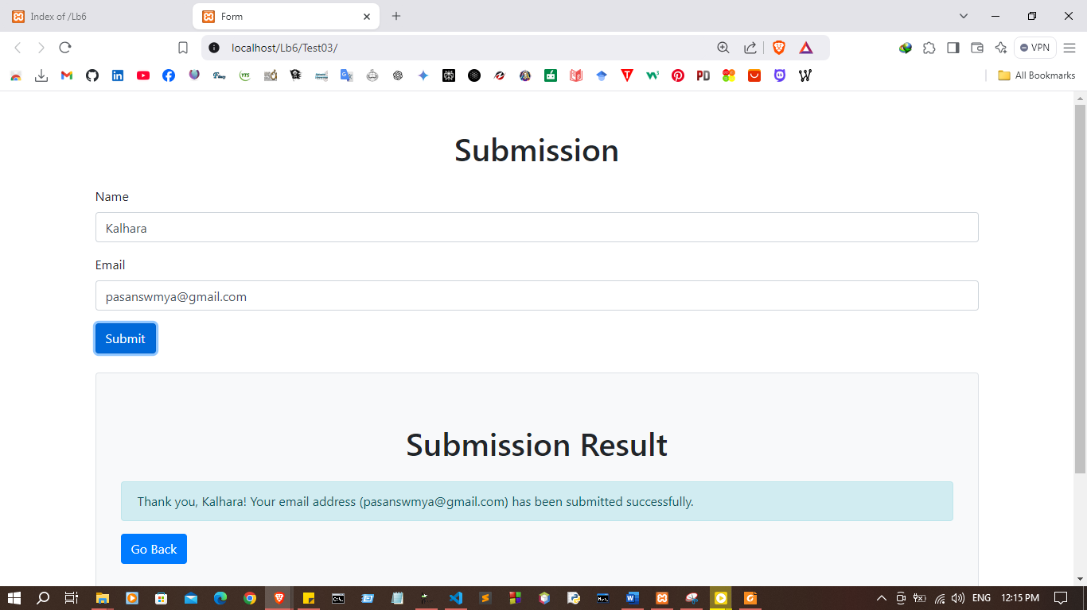

Discussion:

- In this lab session, we focused on mastering the concepts and practical application of AJAX (Asynchronous JavaScript and XML) to enhance user experience through asynchronous request handling. First, we explored making asynchronous requests using the XMLHttpRequest object, which allows data to be exchanged with a server without refreshing the page. Then, we learned to use the modern fetch API for making these requests more efficiently, which provides a simpler and more powerful way to handle network operations asynchronously. By integrating these techniques, we demonstrated how to update web content dynamically without requiring a full page reload, which is crucial for enhancing the performance and responsiveness of modern web applications. Additionally, we saw how AJAX could be used to validate forms in real-time, contributing to a more seamless user experience.

